SAML Configuration

This document defines the parameters required to configure SAML Authentication.
Application ID
This ID uniquely identifies the application being configured for SSO.
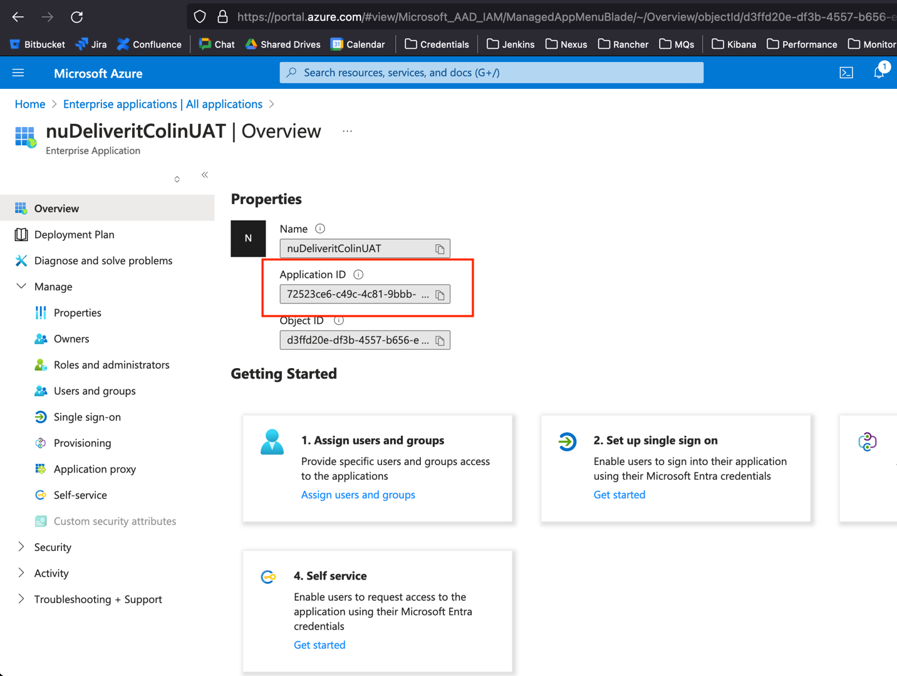

Entra ID
This ID uniquely identifies the Identity Provider. It is used to set the asserting party in the SAML registration.
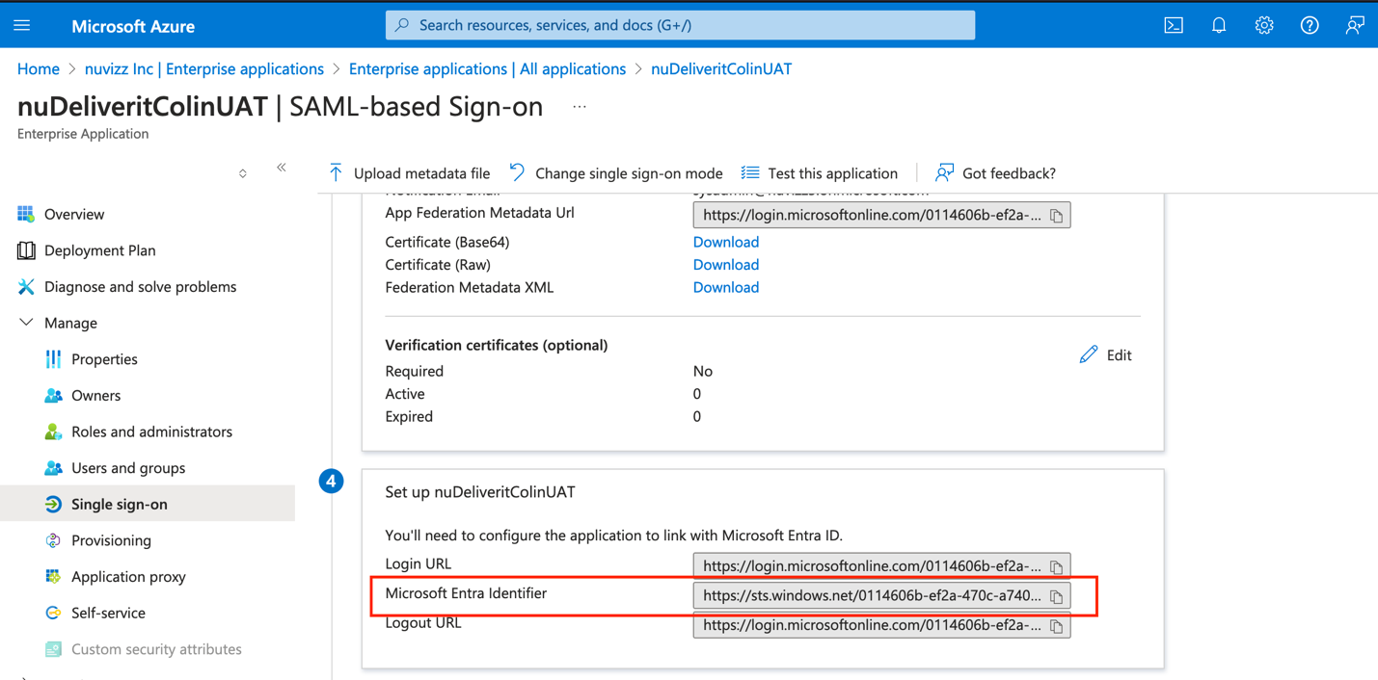

Metadata URI
This provides the location of the SAML metadata file that holds the certificate, schemas etc.
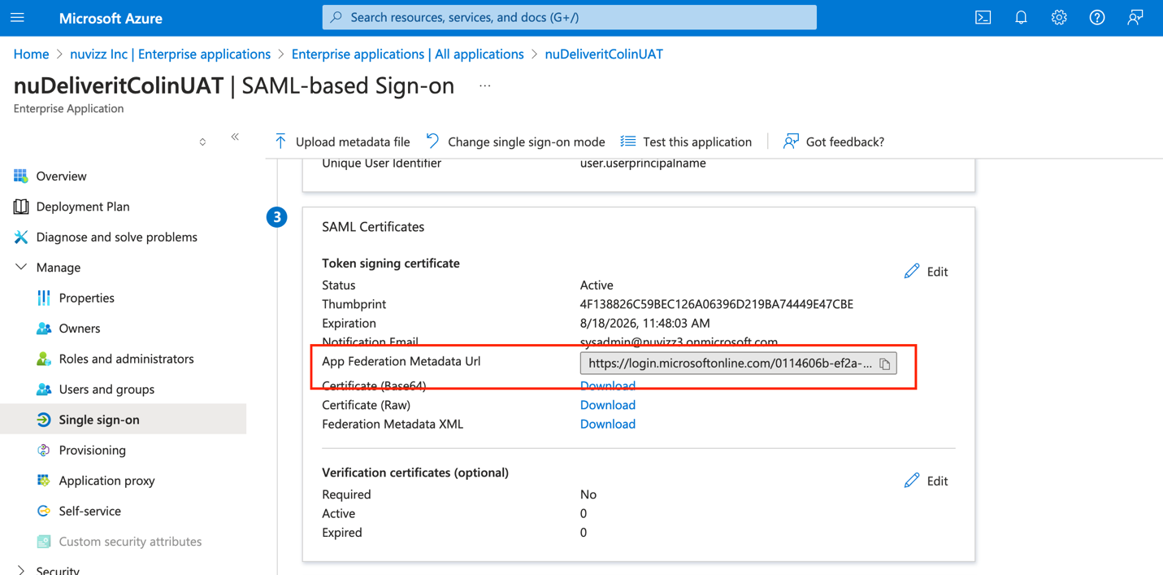

Reply URL
This indicates the URL the SAML provider should redirect to after performing authentication. It has to be configured in the SSO Setup as the Reply URL (or ACS URL)
