# **How to Reopen Closed Stop from nuVizz Dispatcher portal?**

1.Navigate to the Stops screen and select the stop that was closed. Tap on “More Actions” and select "Reopen.”.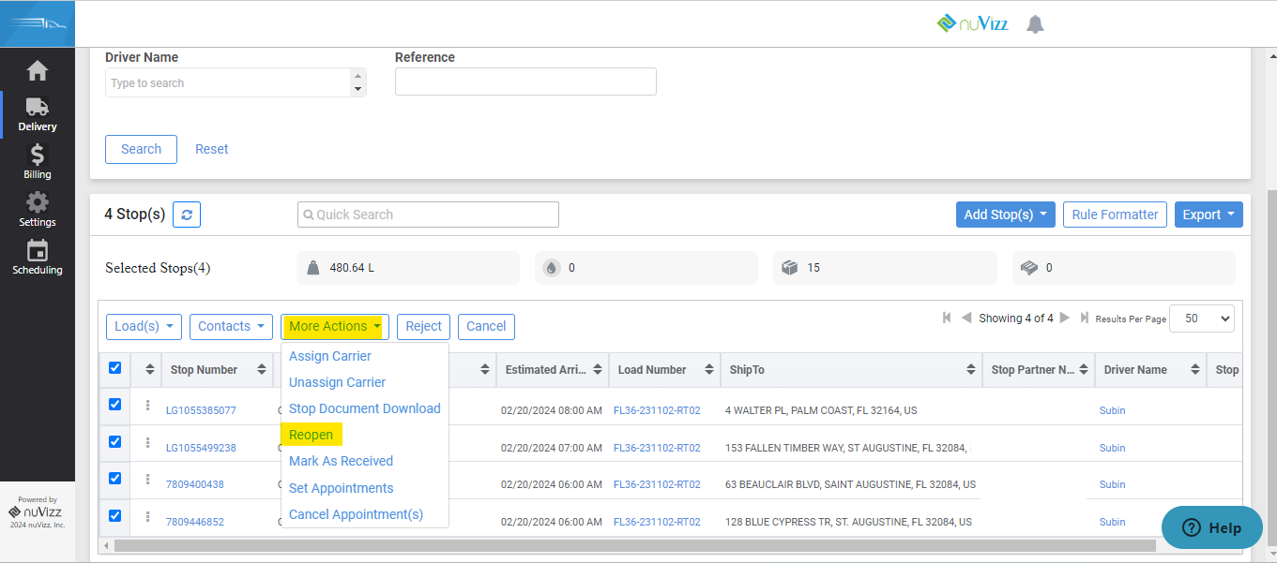

2. A window pops up with a message asking if that stop has to be reopened. Dispatcher clicks on Reopen and Stop moves from closed to Unplanned Status.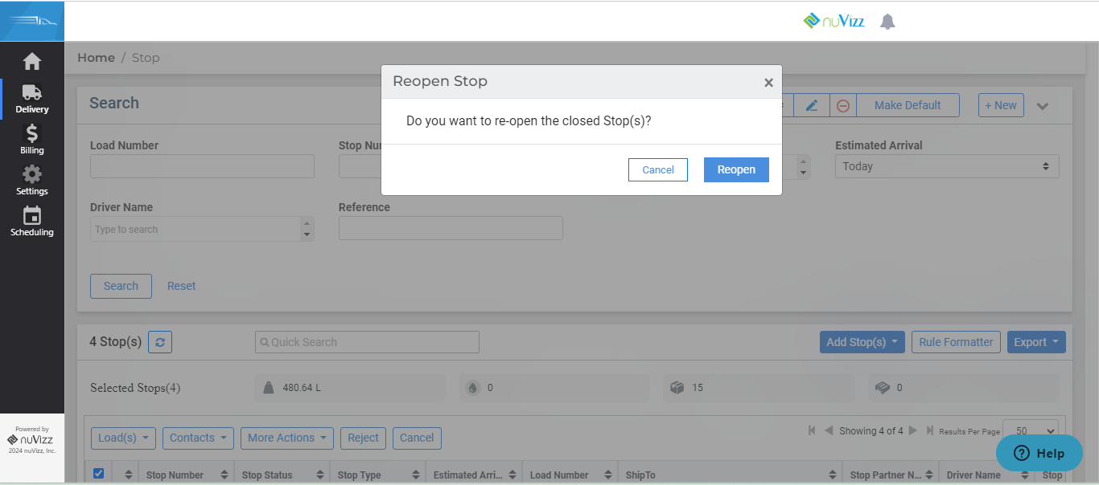

3. You will get a pop-up saying that "Selected Stop(s) reopened successfully"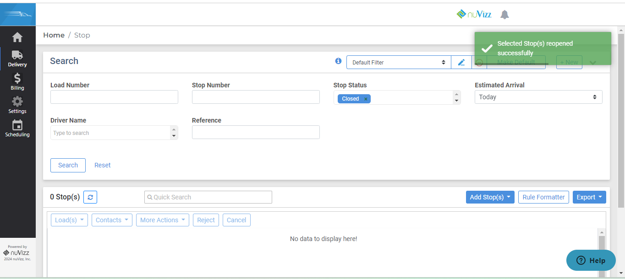

4. The reopened Stop will be seen in the Stop list screen in “Un-planned” status.