Palletize Returns at each Hub
Step | Description | Screenshot
1 | User will click on new menu option Palletize Returns on the nuStockIt app. | 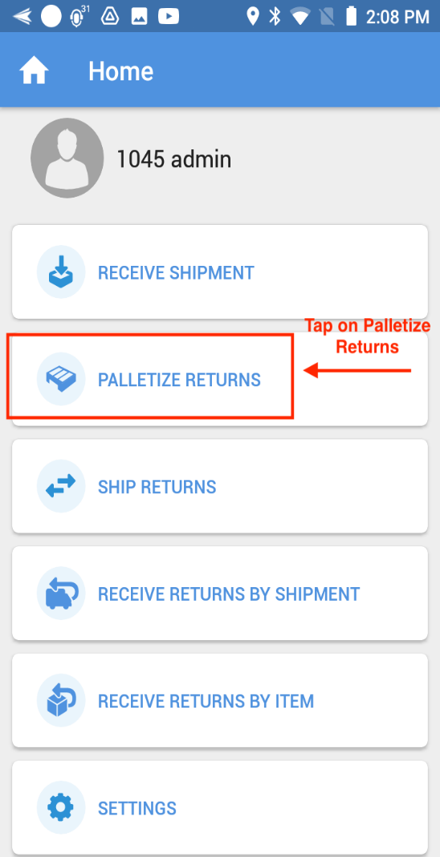
PALLET SCAN: 3 WAYS
1A | Camera Scanning:  - User will scan a pallet id by clicking on the barcode icon (2) in the pallet id field. | 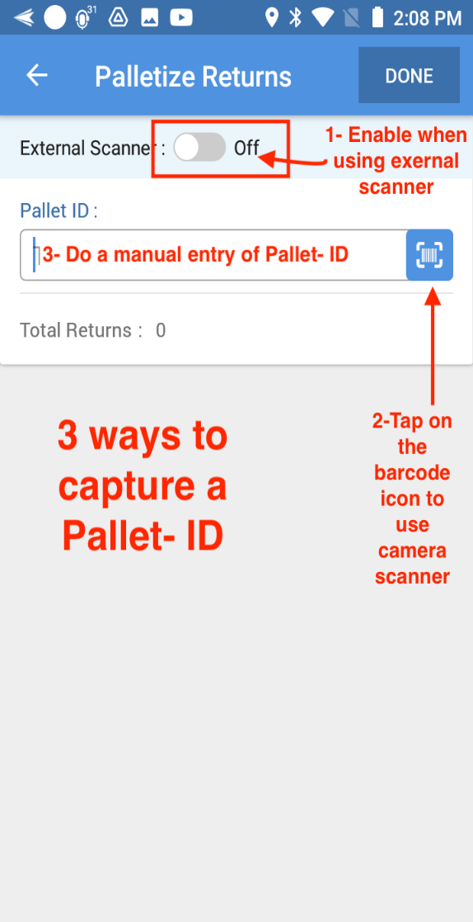
1B | User will be directed to scan pallet id screen. They can click on back button and come to the palletize returns screen | 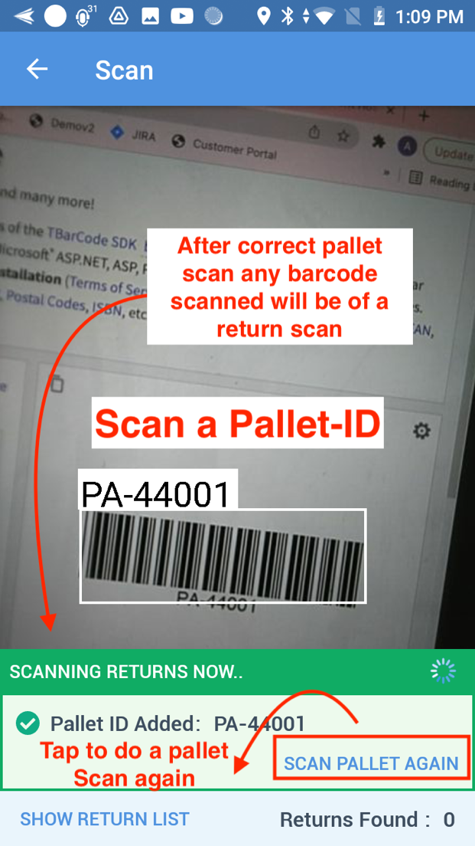
1C | - Once User scans a pallet id, then the scanned pallet id will be shown in a card below in the scan screen with two options as "Scan Pallet Again" and "Show Return List". It will also show "Scanning Returns Now" to indicate to the user that henceforth, the scan will be considered for cartons.  - Choosing "Scan Pallet Again" will treat the scan as Pallet Scan because once a successful pallet scan has happened, the next scans are automatically treated as cartons
RETURN CARTON SCAN
1D | - After a successful pallet id scan, users can continue scanning return cartons as such.  - The total count will be shown under the "Returns Found". | 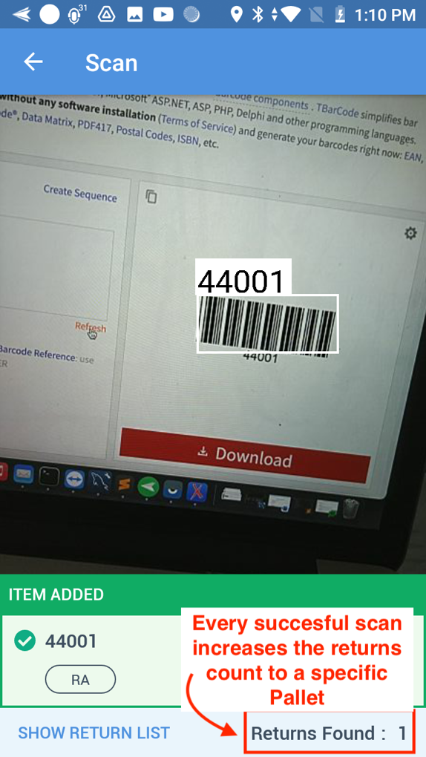
1E | If the portal identifies that it’s not a valid return carton then it responds back with an error. The app will then show a card at the bottom to the user as "Return not Found". | 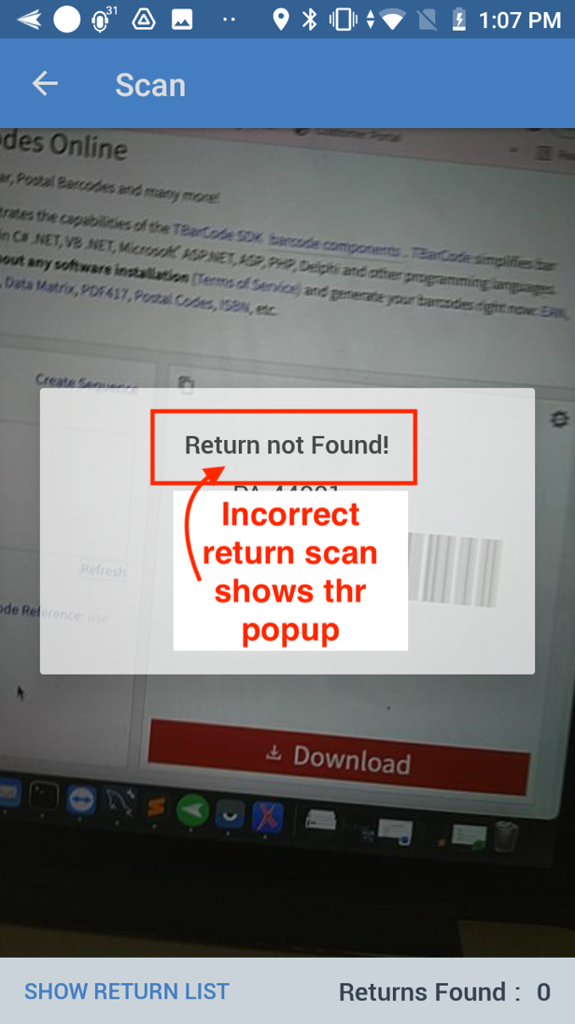
REMOVE RETURN CARTON
1F | - Clicking Remove in the return carton list page allows users to remove a carton. If a user accidentally removes something, they can always add it again.  - In the return carton list page, there will be an option to scan(barcode) or manually add return id. This is like the Pallet ID field. Choosing "barcode" option in the return id field will flow through the same steps as before. | 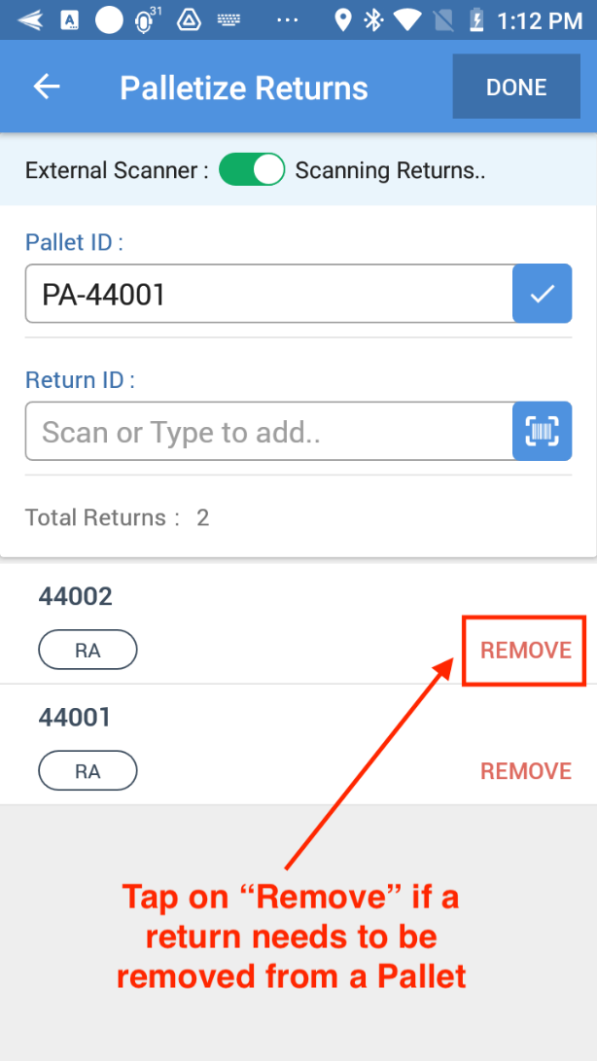
EXTERNAL SCANNING: PALLET SCAN
2A | In the return carton list page, there is an option to switch on the External Scanner (1). Once the external scanner is turned on then the scan option at the pallet id will be hidden and the two options at the bottom of the page such as "Scanning Returns" and "Add Manually" will also be hidden. | 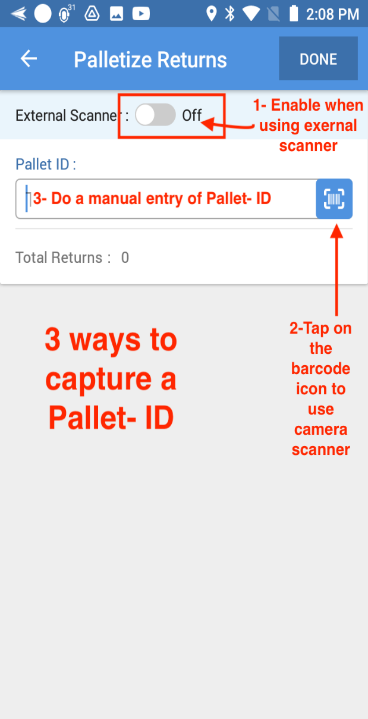
2B | - Scanning via external scanner (1 in screenshot) will treat the first scan as a pallet scan, will show the label as "External Scanner: Scanning Pallet" to let the user know that the pallet id is being scanned.  - After the first scan, the secondary scanning and so on will be treated as return carton  - Choosing "Refresh" near the pallet id will treat the external scanning as pallet scanning again and will clear whatever the return cartons are showing in the page as it will be treated as a new pallet id scan | 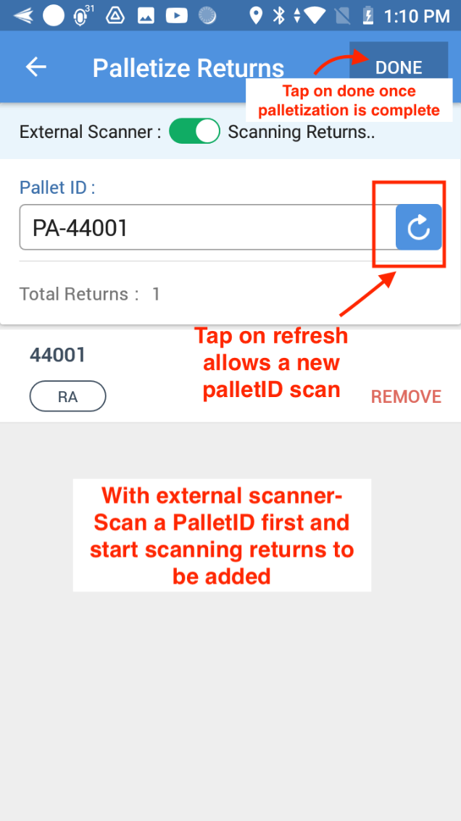
ADDING PALLET ID MANUALLY
3A | - The user can also provide the pallet id manually(3), if the user deletes the scanned pallet id and starts typing the pallet id then the scan button or the refresh button at the pallet field will be hidden and a check mark option will be shown.  - Once the pallet id is entered manually, the user can choose the "Check Mark" that will fetch the list of cartons under the pallet, and they will be shown in the list below. This will also make the returns field visible to the user where they can start adding the return cartons either via scan or manual entry.
 | - Once the pallet id is entered manually, the user can choose the "Check Mark" that will fetch the list of cartons under the pallet, and they will be shown in the list below. This will also make the returns field visible to the user where they can start adding the return cartons either via scan or manual entry. | 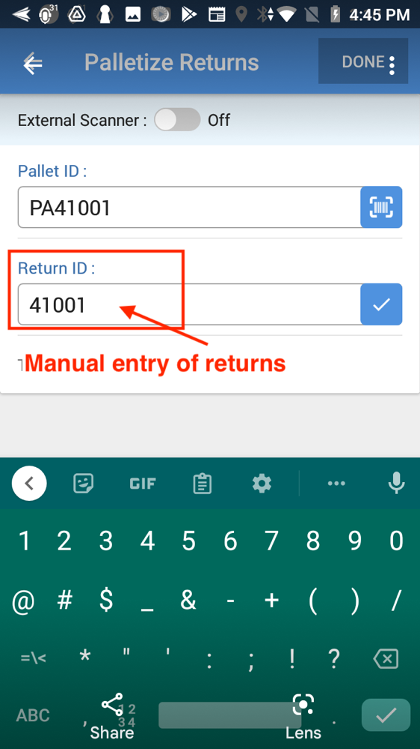  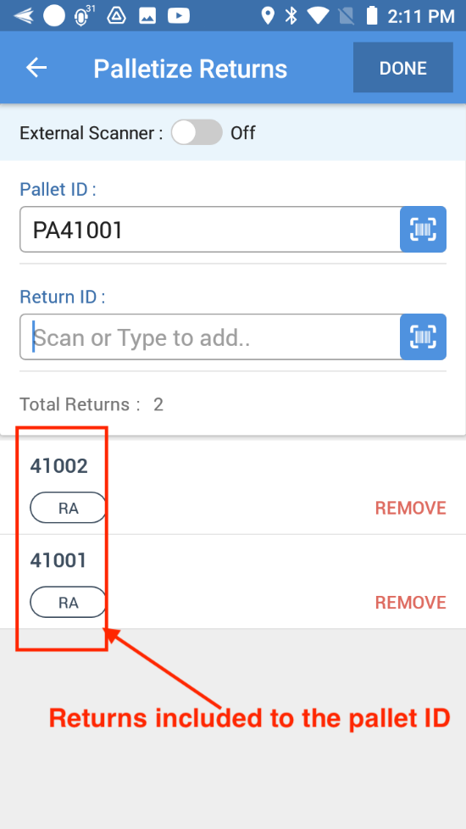

Ship Returns- Create Returns Load

Step | Description | Screenshot
1 | User will click on Ship Returns menu option on the nuStockIt app. | 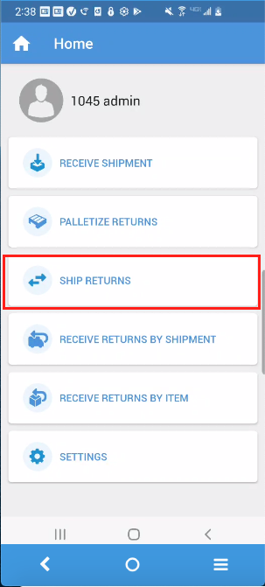
2 | - User will select "Return Shipments" Tab under Transfer Returns  - The Return Shipments Tab will provide an option to filter the stops based on the DC listed in the dropdown. | 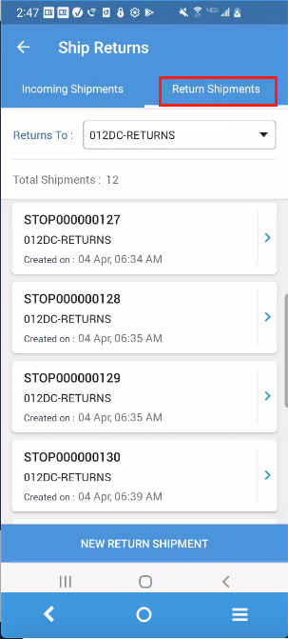
3 | - Depending upon the DC selected from Drop Down, the stops are shown in the list below.  - Each stop card will show the stop number, the corresponding DC and the date it was created on | 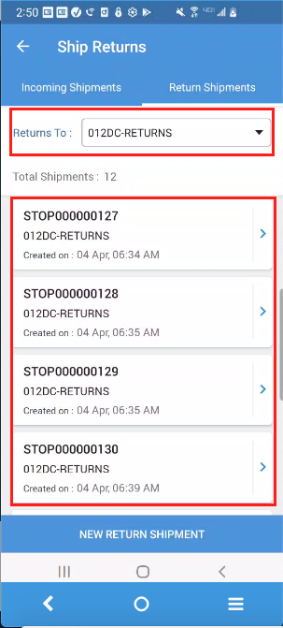
4 | NEW RETURN SHIPMENT  - User will click on "New Return Shipment" button to create a new return shipment | 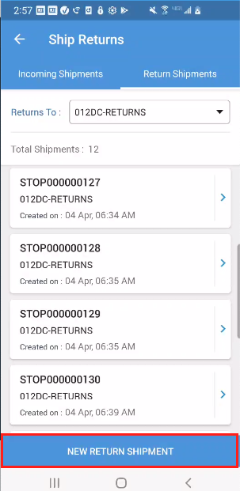
5 | - User will be directed to new return shipment screen.  - They can select the desired DC from the drop down. When only one DC is associated, the DC will be defaulted | 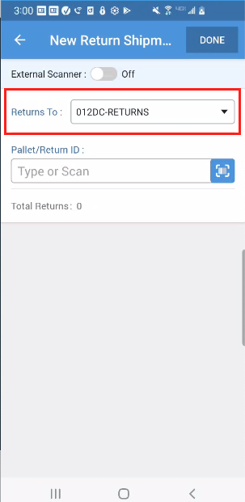
6 | - User can click on Scan icon to start scanning Return cartons or Pallet Id.  - There is no separate option to scan a pallet or a carton. | 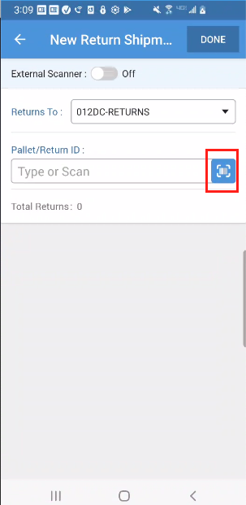
7 | SCAN RETURNS  - As soon as the pallet or carton is identified as valid, the new stop is created to be shipped to the selected DC and the scanned cartons are added to it as its stop details.  - It will also create a new route on which the scanned returns will be planned on. Created Route will be visible on the nuDeliverIt Dispatch Portal  - The return carton will be identified and displayed as item added when scanned.  - When user scans a pallet id, pallet will be identified and displayed as item added.  - The number of cartons that user added by scanning a pallet id will be displayed under the field "Returns Found".  - Note: If no valid carton or pallet was found then the card will show the message as "ITEM NOT FOUND". | 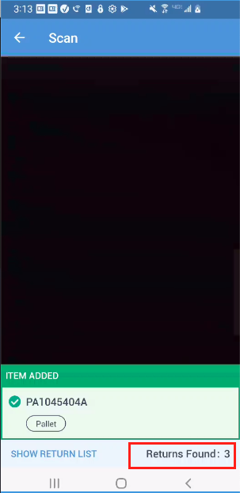
8 | - When the user chooses "Show Item List" or if the user goes back, list of all returns added under that stop will be displayed.  - The user will be directed to the "Return Shipments" page. | 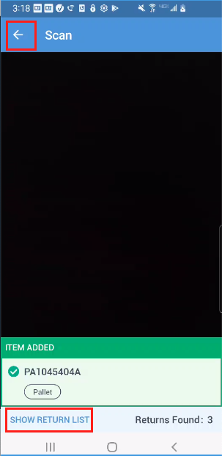
9 | - User will be now directed to New Return Shipment Screen where all the scanned cartons/pallet will be listed out. The title of the page will be shown with the stop number.  - User can either remove them by clicking remove or click on scan again to add more cartons/pallet to the same shipment. | 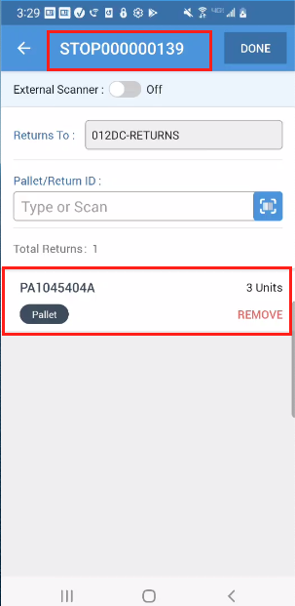
10 | SCAN RETURNS VIA EXTERNAL SCANNER  - In the New Return Shipment Screen, there is an option to switch on the External Scanner.  - Once the external scanner is turned on then the field to add the return item will be hidden.  - User will be now able to scan returns or pallet id using external scanner, the returns and pallet added will be displayed in the list. | 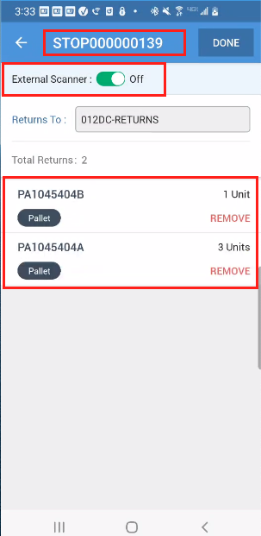
11 | ADDING RETURNS MANUALLY  - User can add returns or pallet id by entering the value in the Return ID text box. When the user starts typing the id in the field, the scan option will be hidden and replaced with a check mark.  - Once the check mark is chosen, the corresponding return carton or pallet will be shown in the list. | 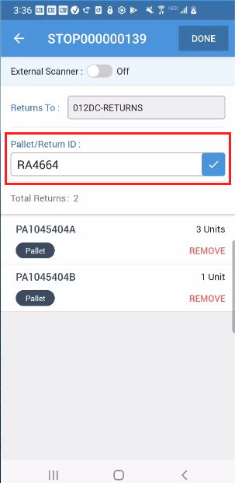
12 | - Once the user is done with adding the Pallet/Return to the new shipment, user can click on Done button and come back to the “Return Shipments” screen | 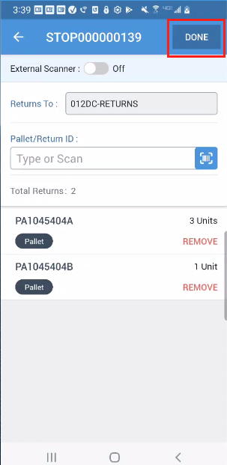
13 | ADDING RETURNS TO EXISTING SHIPMENTS  - User will be able to select DC from the drop down to view the list of shipments.  - User can click on any shipment to continue adding new cartons/pallet id or remove cartons/ pallet id from the shipment. | 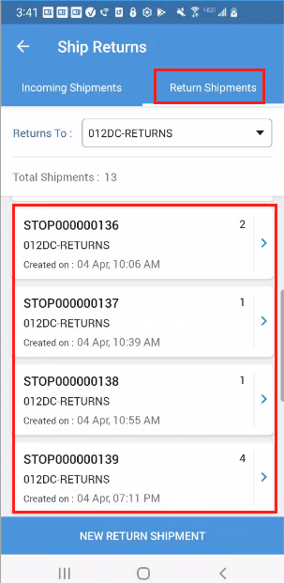
14 | - Once the user selects a shipment, then all the returns under that shipment will be fetched in the next page along with its profile. The selected Stop Number will be displayed at the top. User will not be able to change the profile as the stop is already created.  - The profile option will be greyed out to indicate that the user cannot change it. NOT INDICATED IN THE MOCKUP. | 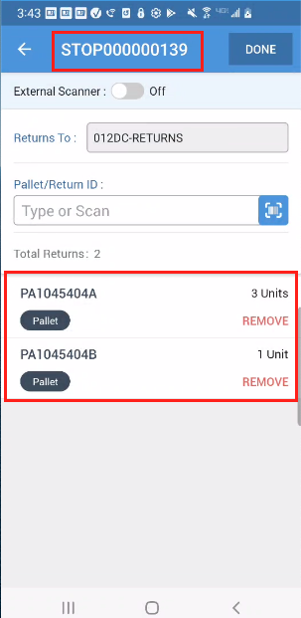

Assign Driver to Returns Load (Dispatch Portal Hub company)
1. | User selects Assign loads Menu item under “Delivery”. For the specific return load click on the driver’s name column’s field | 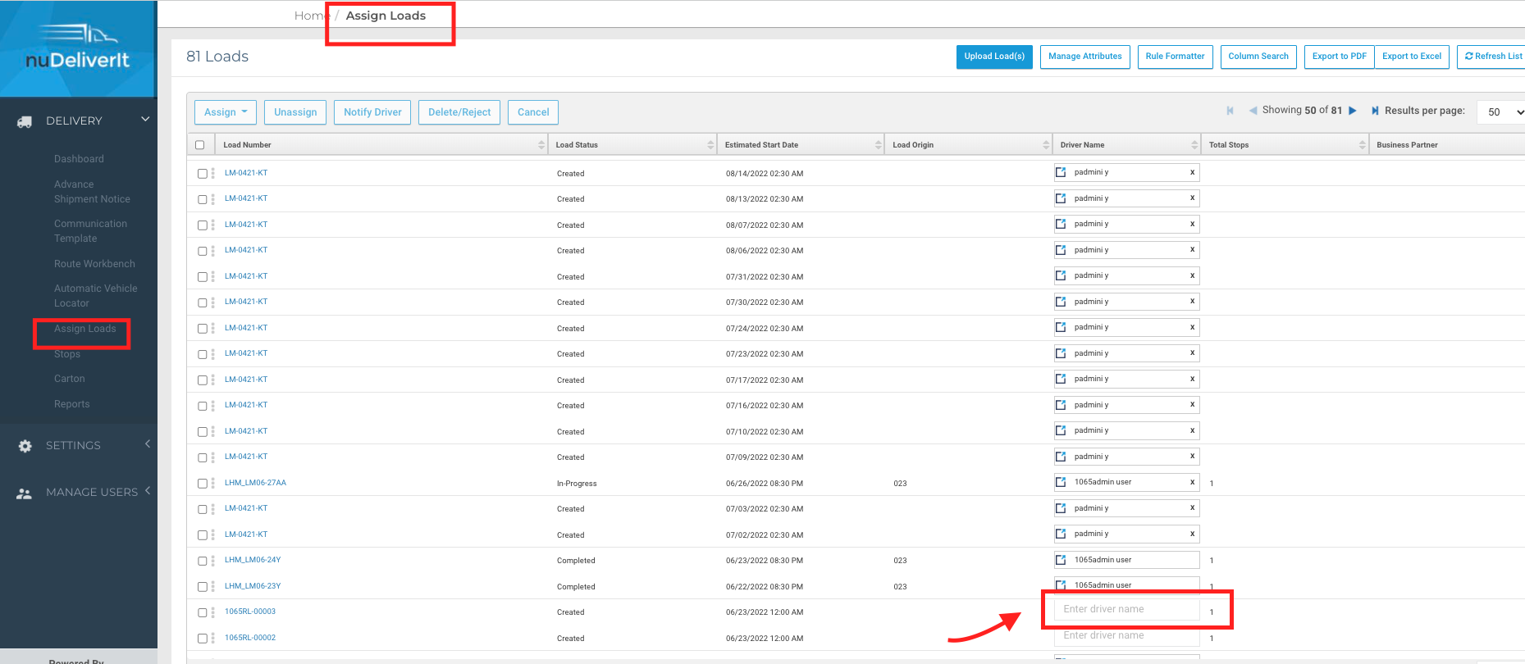
2. | From the drop-down list of drivers select the required driver name. | 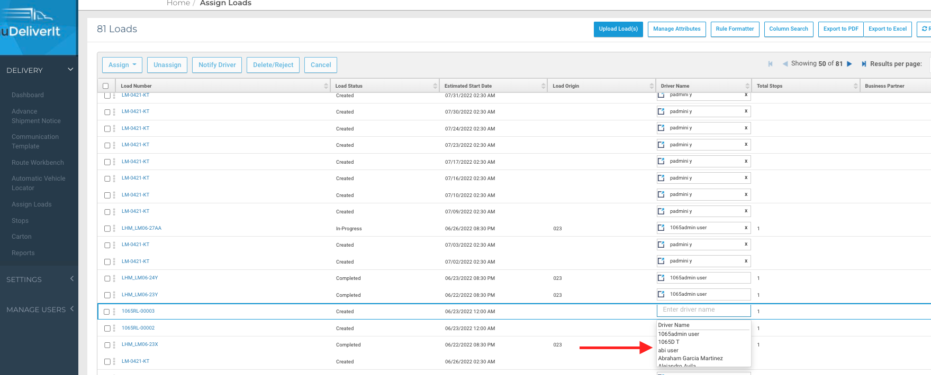
3. | Driver assignment when successful shows a popup notification on the top right | 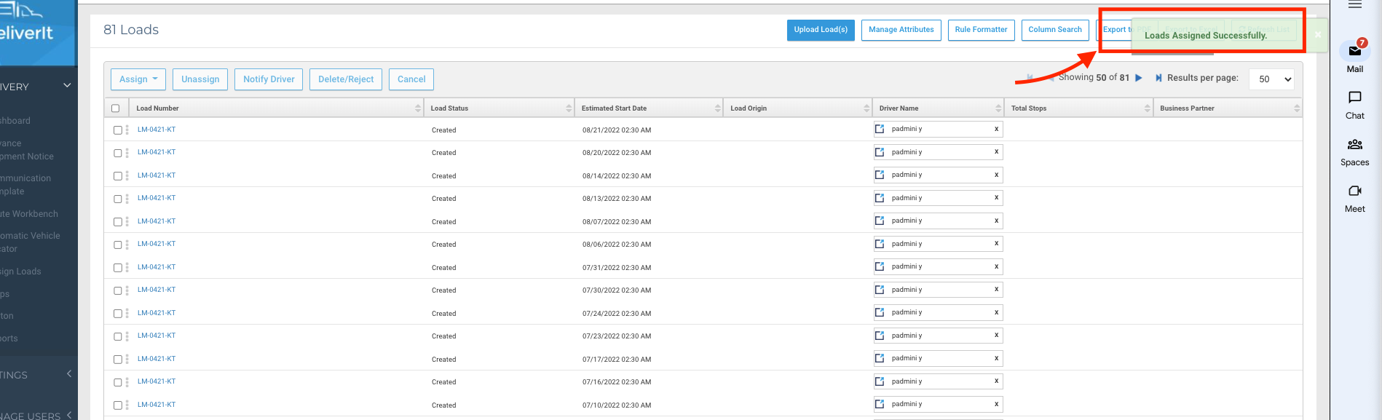

Receive Returns by Item
1 | User will click on "Receive Returns by Item" menu option on the nuStockIt app. | 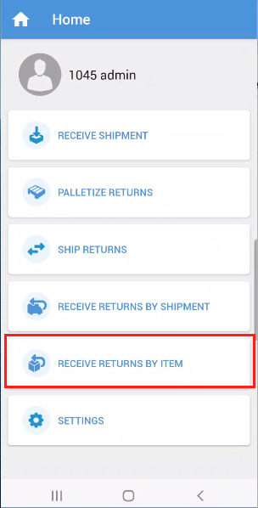
2. | - User can click on Scan icon to start scanning Return cartons or Pallet Id.  - There is no separate option to scan a pallet or a carton. | 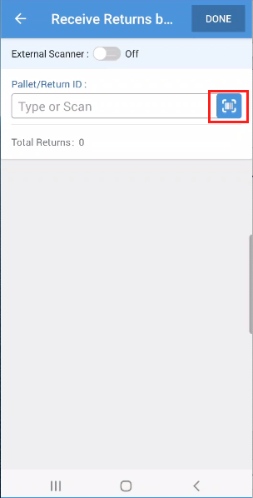
SCAN RETURNS
3. | - The return carton will be identified and displayed as item added.  - Note: If no valid carton or pallet was found then the card will show the message as "ITEM NOT FOUND".  - Once all the rerurn cartons/ pallets have been received against the return shipment then "8500 - Returns Receive Event" will be triggered. | 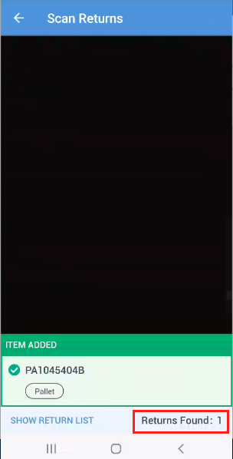
4. | - When the user taps on the "Show Return List" or the back button, the user will be directed to the "Receive Returns By Item" page where the app will show the list of scanned cartons or pallets. | - 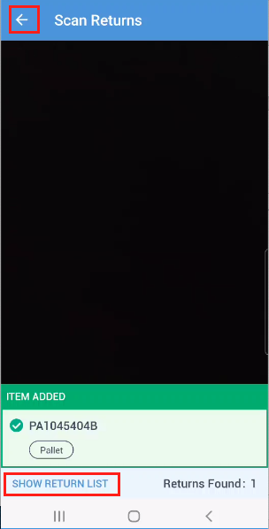
5 | - User will be now directed to “Receive Returns By Item” Screen where all the scanned returns/pallet will be listed out.  - User can click on scan again to receive more returns/pallet. | 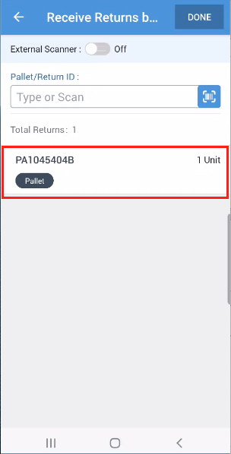
6 | SCAN RETURNS VIA EXTERNAL SCANNER  - In the Receive Returns Screen, there is an option to switch on the External Scanner.  - Once the external scanner is turned on then the field to scan/enter the return item will be hidden.  - User will be now able to scan returns or pallet id using external scanner, the returns and pallet scanned will be displayed in the list. | 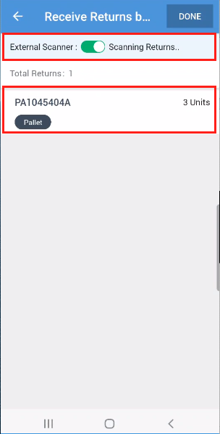
7 | - Once the user is done with receiving the returns/pallet id across various return shipments, they can click on Done button and come back to the Home screen. | 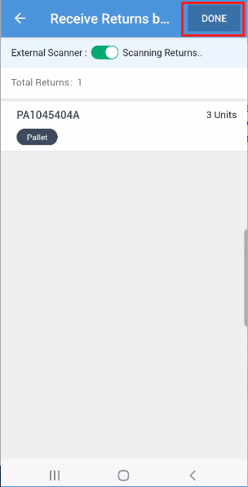
8 | ADDING RETURNS MANUALLY  - User can receive returns or pallet id by entering the value in the Return ID text box. When the user starts typing the id in the field, the scan option will be hidden and replaced with a check mark.  - Once the check mark is chosen, added pallet or a return carton will then be shown in the list. | 