|  |
| --- |
| AIT Worldwide Logistics |
| **AIT Mobile** |
| NuVizz Dispatch Process |
| **In this manual, you will learn how to dispatch a delivery utilizing the AIT Mobile app which allows for the flow of timely information** |
|  |
| **7/9/2018** |

|  |
| --- |
| *© Copyright 2014 by AIT Worldwide Logistics, all rights reserved.*  *All materials appearing in this manual may not be reproduced or stored in a retrieval system without prior written permission of the publisher and in no case for profit.* |

Contents

Access NuDeliverit Dispatch Site 3

Dispatch Process 4

Commonly used functions…………………………………………………………………………………………………………………………….9

Add/Edit user information (Administrators only)……………………………………………………………………………………….13

# Access nuDeliverIt dispatch site and Login

From your Google Chrome browser, add the following URL String:

<https://nuvizzapps.com/deliverit/>

Enter your company name, user name and password given to you by the administrator and hit LOGIN. (3)

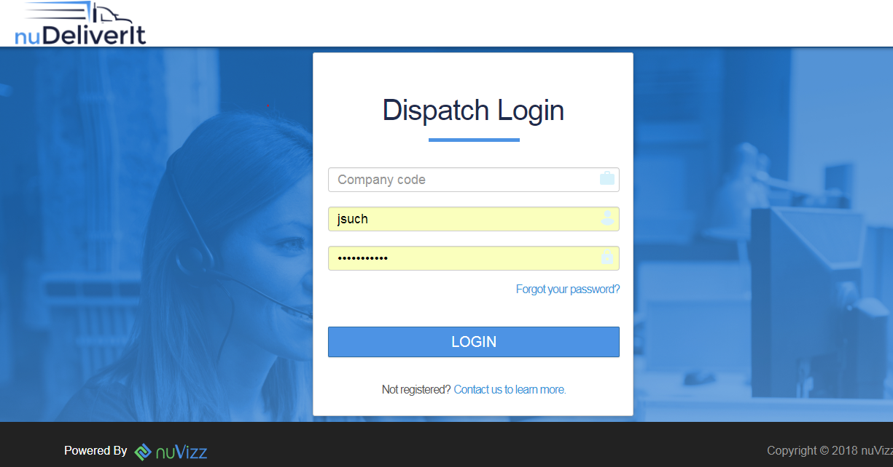

This screen is considered your home page. From here, you will select Delivery and hit the option needed.

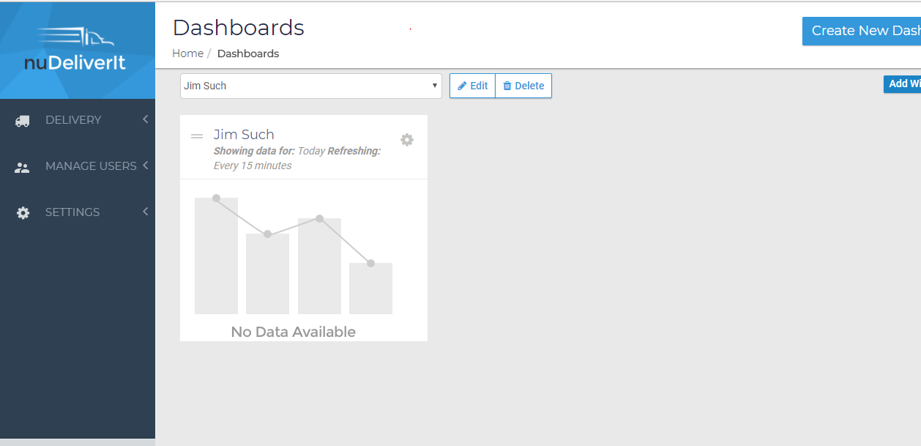

When you select Delivery, your options will appear. You can go into your “Stops” to process a manifest or “Assign Load” to assign a load that was saved and ready to dispatch.

# 

# Stops

Once in the Stops screen, you can type in your house bill number as previously done (separated by a comma) and search for the selected house airway bill list.

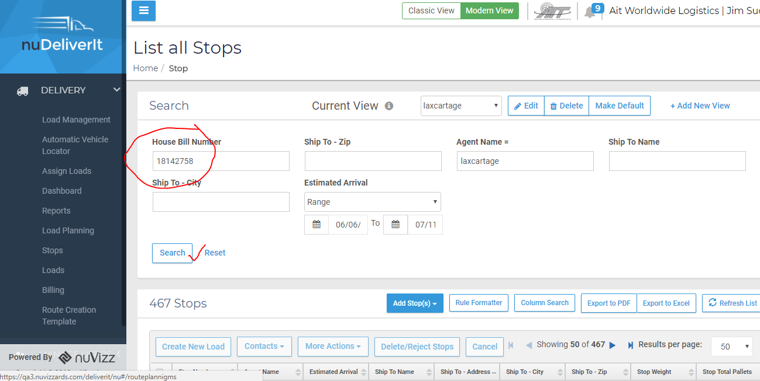

When you have entered your search and your selected bill(s) have appeared, select the stop and you will be able to proceed to Create New Load.

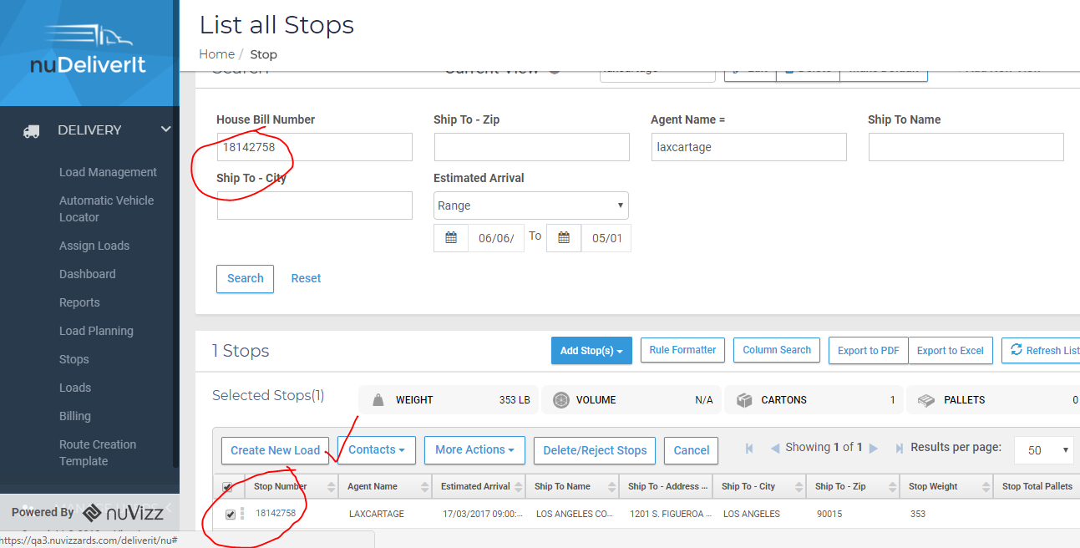

When you select to Create New Load, you will go to the Origin page (as previously done)

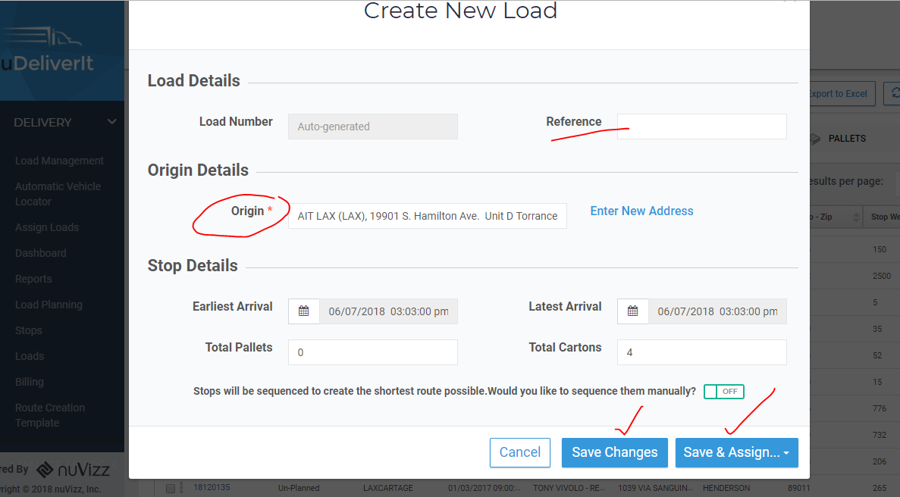

Screen operates same way as in Classic View- you will have option to type in the route reference (free form), start to type your Origin (first few letters) and it will auto-populate. Select Save or Save and Assign.

When you select Save and Assign, you will be given your independent route number. You will be asked to select a driver by typing in the user (driver) name. All matches will appear and you would select the driver and Save Changes.

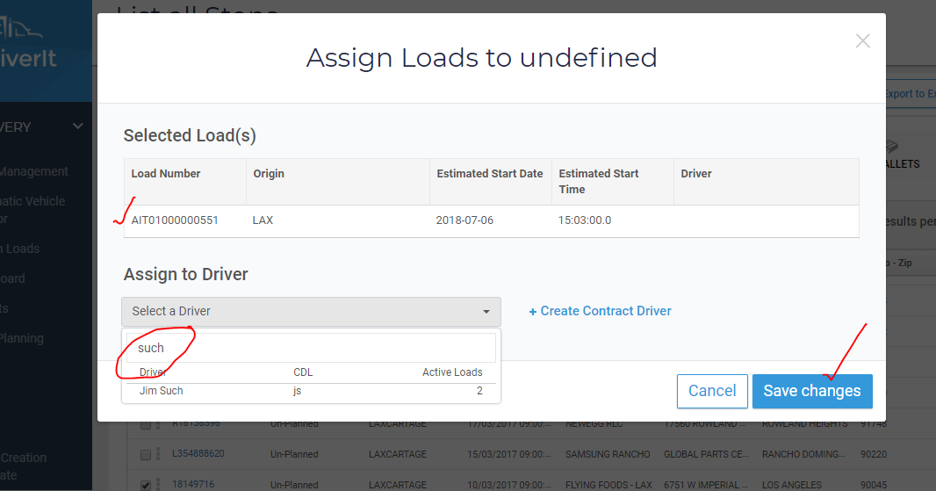

After you have saved the route to the driver- return to the main menu and select Assigned Loads.

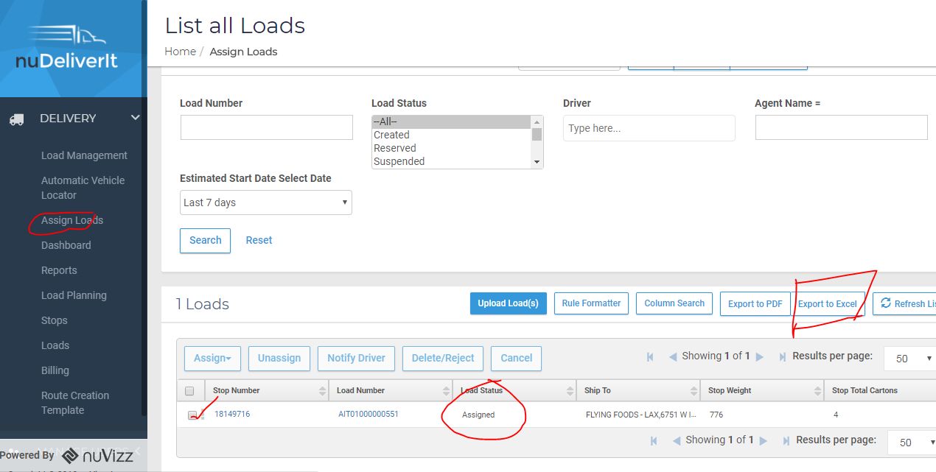

Find the load you assigned, select Export to Excel and open in Excel. This will allow you to copy and paste onto an AIT Manifest document for the driver.

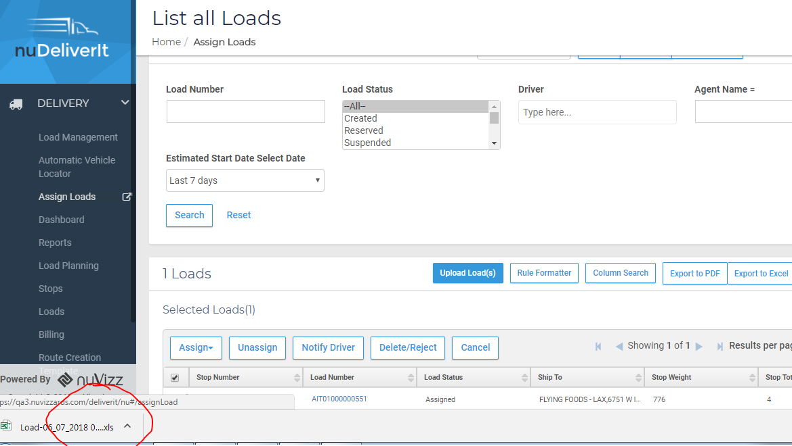

Select the Excel Spreadsheet to open.

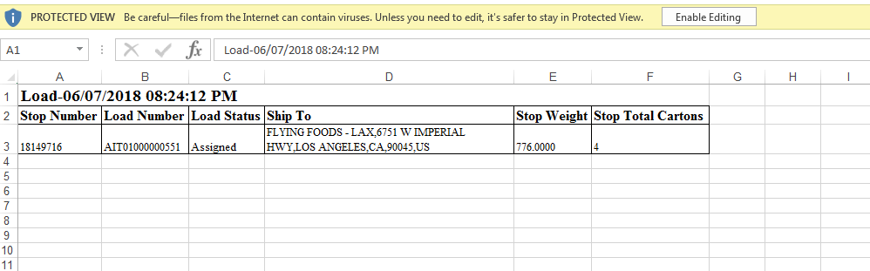

Copy and paste to the blank AIT Manifest Document.

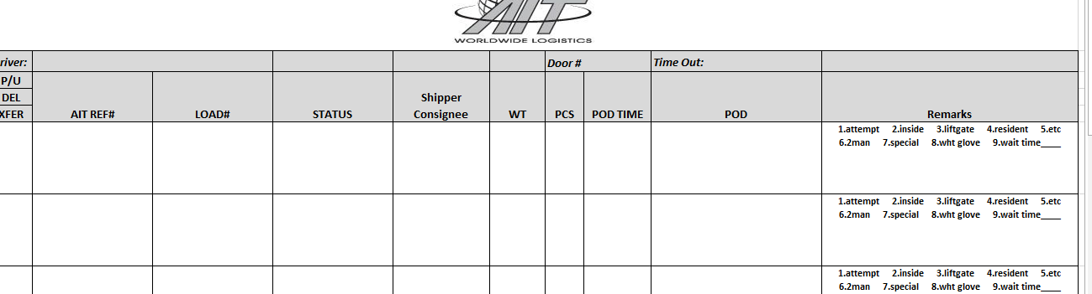

Commonly used screens and functions:

House bill look up with POD information:

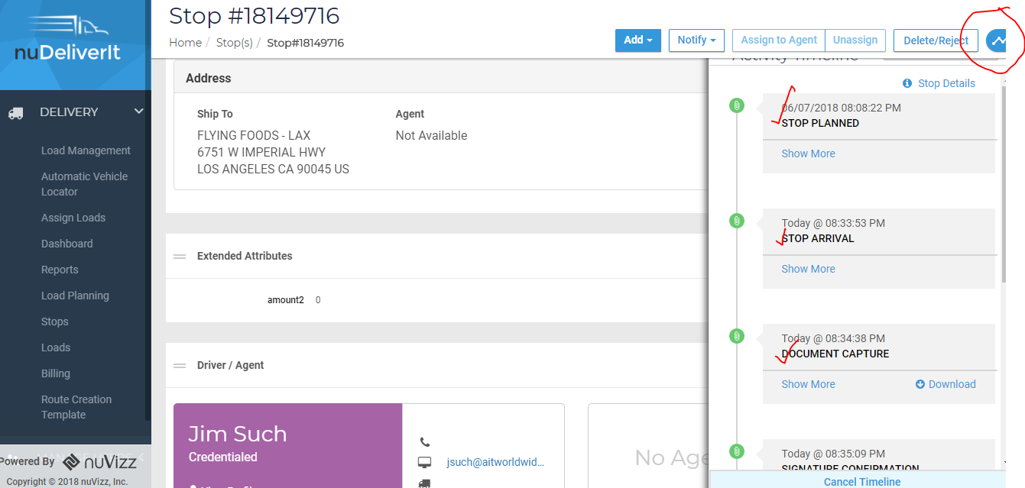

When you pull up a bill information and click on a bill number, this screen will appear. Click on the status line (circled above) to open the string of events.

You can select the event that you wish to open by selecting “Show More” as seen below. This includes “Document Capture”, which is pictures taken during the pre-stop or stop exceptions.

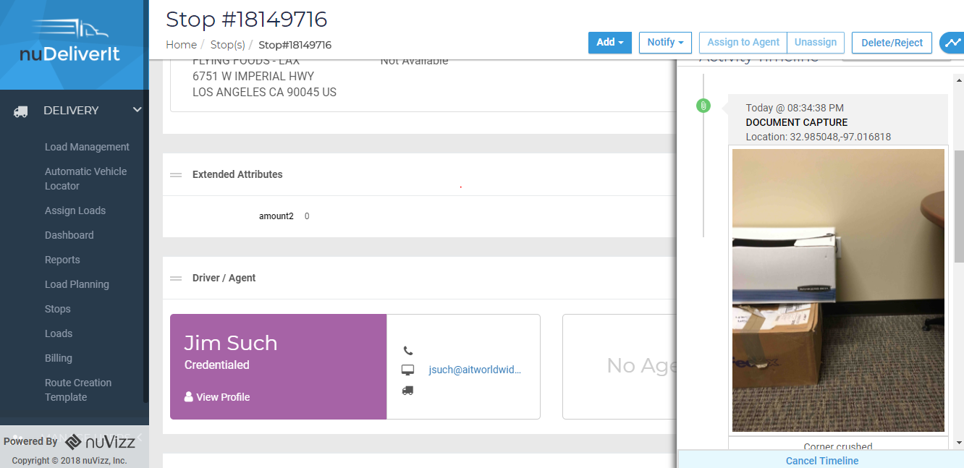

You can also see the POD information as show in the Classic View by selecting Show More under the Signature Confirmation tab.

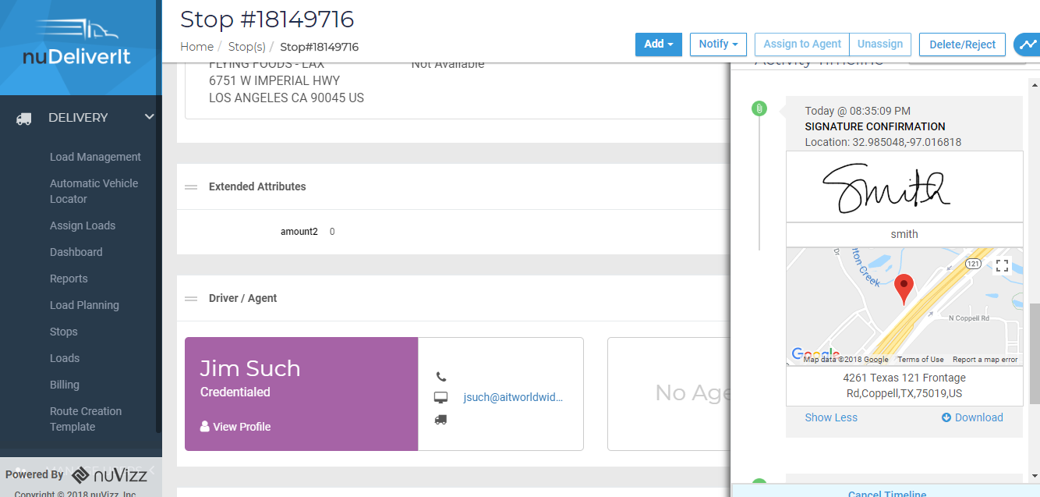

Market Dashboard View

To view the market you are in and where trucks are presently located (as previously displayed in your dashboard view), see the following:

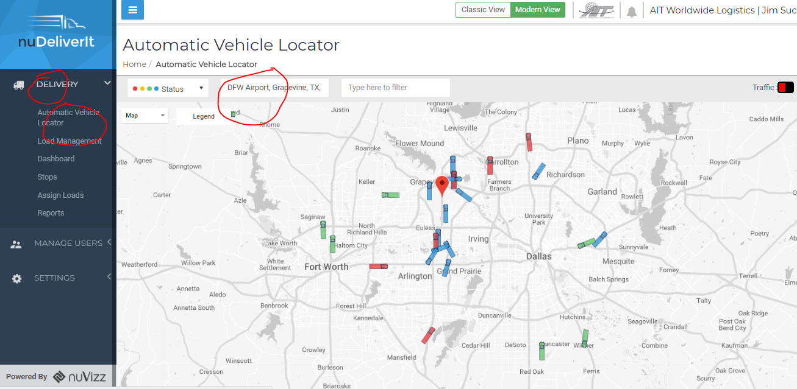

Color definition is listed in the Legend field.

Dispatcher-Driver Communication

To communicate directly with driver via NuVizz, select drivers route and then select Notify Driver.

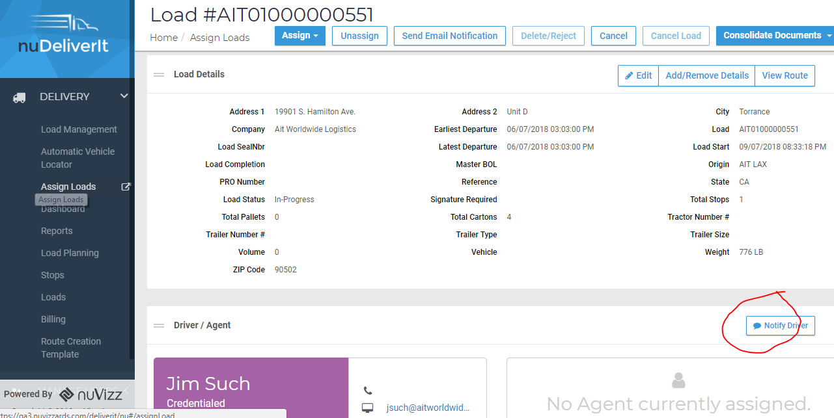

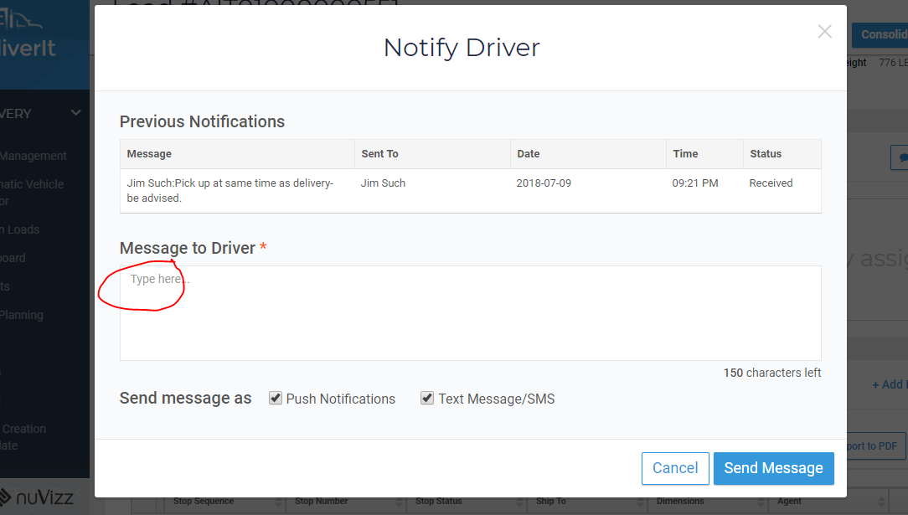

You can see both previously communicated messages and add new messages. Will appear on drivers app as seen below.

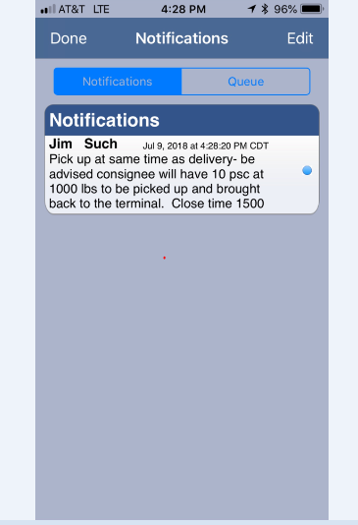

Add a driver/user or edit driver/user information (password).

When you have administrative rights, you can add/edit driver/dispatcher information from the screen below.

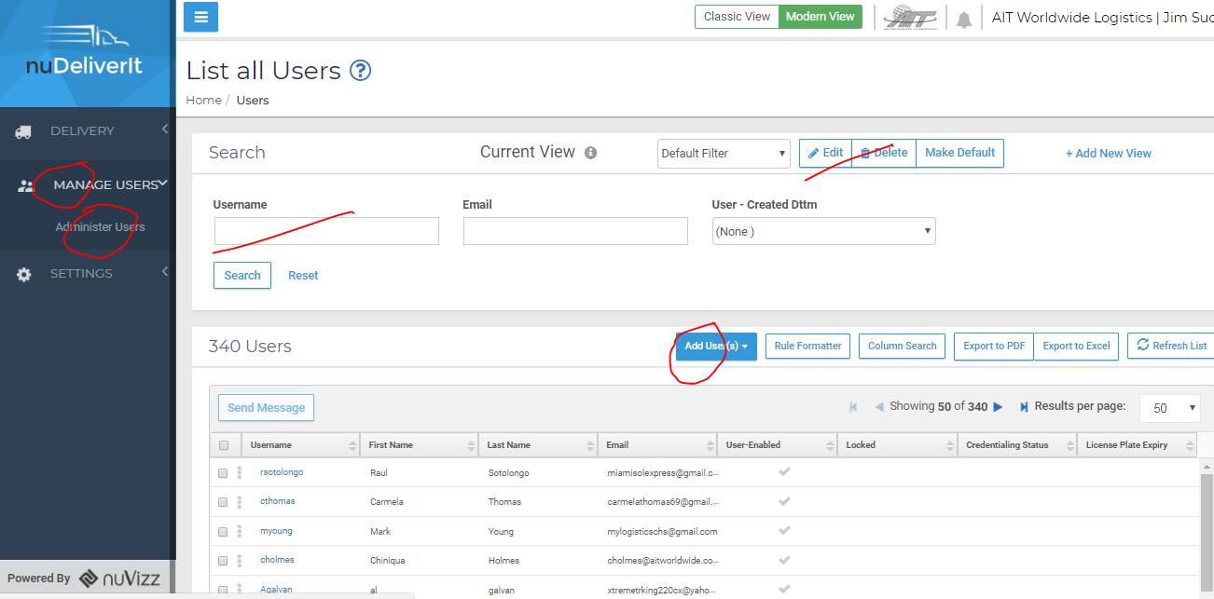

To add, select Add User, to edit a present user, do a search on the user name and select Edit.

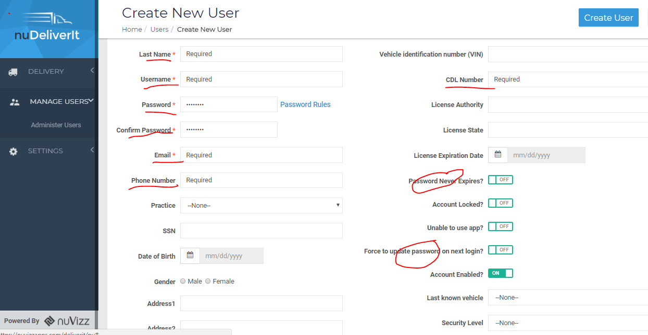

Bottom Half of Screen:

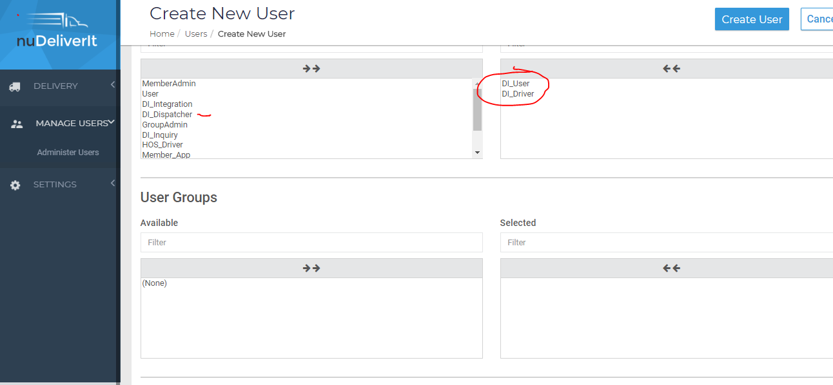

If Dispatcher, slide DI_Dispatcher over instead of DI_Driver, but always use DI_User.

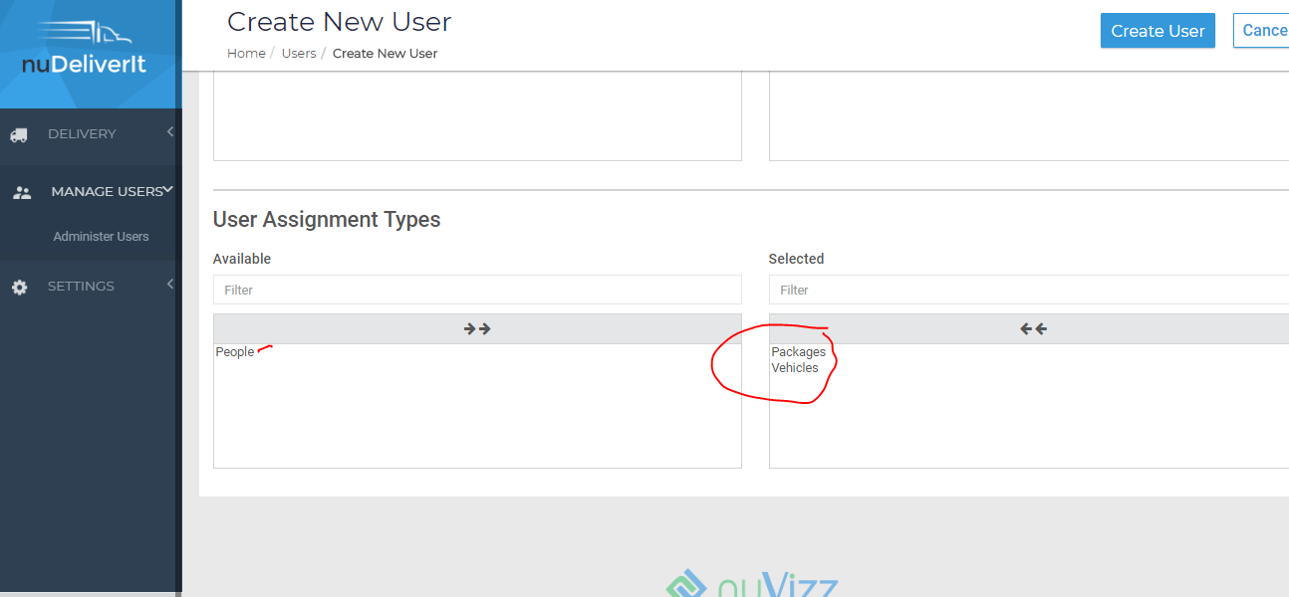

For Dispatcher, use People/Vehicles, Drivers use Packages/Vehicles.